Guideline of Truck Routines
Route map of exhibitors' trucks entering the exhibition venue: 请please contact the Operation Department of MetalForm China Division of CCMI before transporting goods, apply for vehicle pass, confirm the exhibition hall and plan the route carefully.

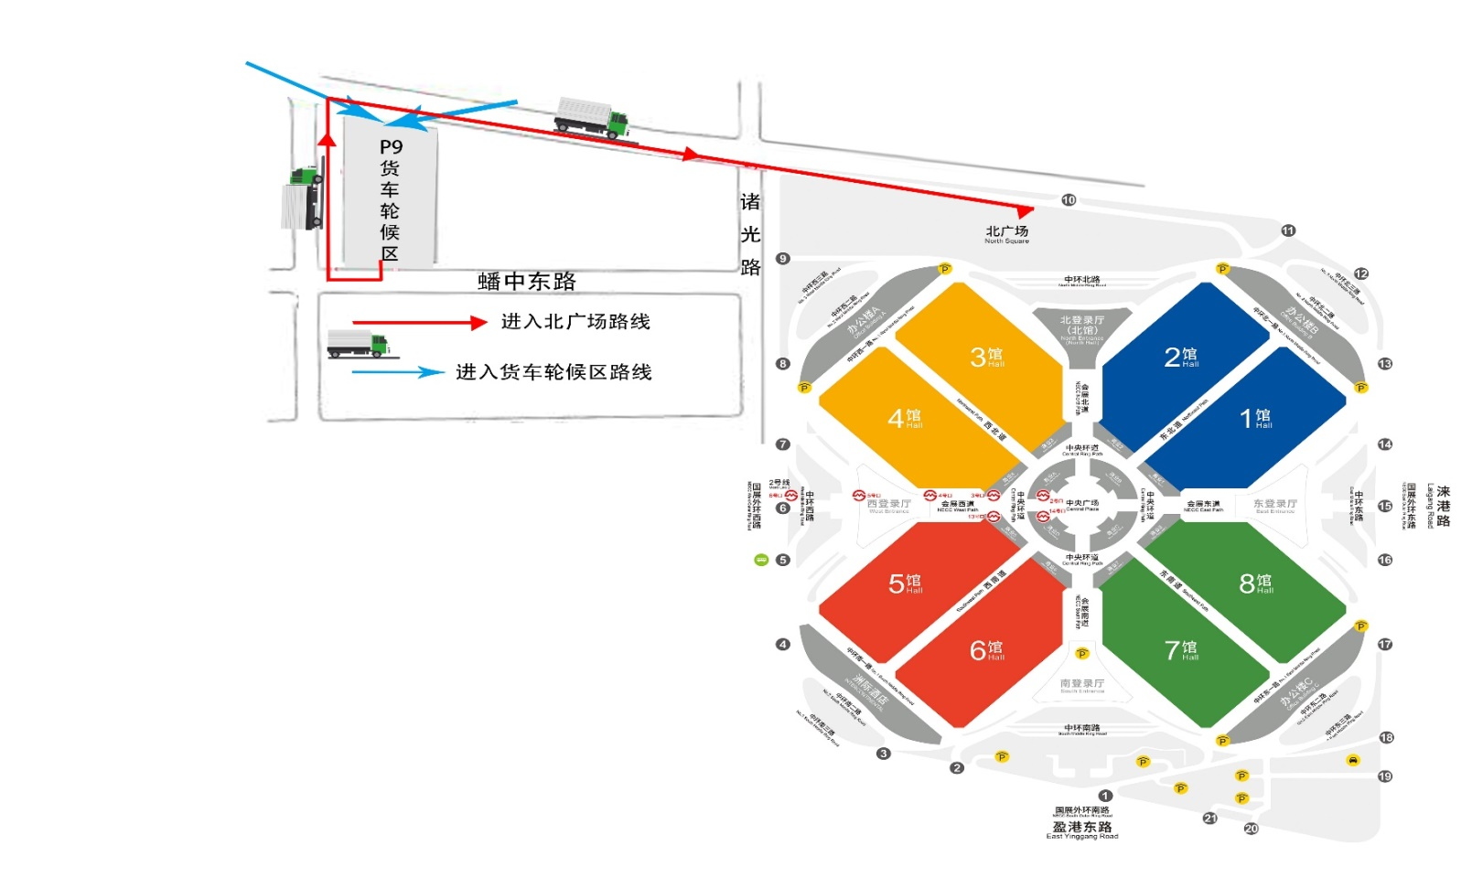

Bus route: if it is necessary to use bus to transport personnel, please use the following map to plan the route. With a parking permit, you can take the following route and park. Please contact the Operation Department of MetalForm China Division of CCMI before the exhibition, confirm how to apply for the bus pass, and plan the driving route according to the map below.

