Application Form
MetalForm China

Please carefully fill this Form to be sent to:
MetalForm China Division, Confederation of Chinese MetalForming Industry
10/F Boya Tower C, Zhonguancun Life Science Park, Beiqing Rd.,
Changping, Beijing 102206, P.R.China.
Tel:：+86 10 5305 6669
Fax： +86 10 5305 6644
Email：metalform@chinaforge.org.cn
We apply to join MetalForm China ，Our main business concerning the followings selected（Please tick the box selected with“√”）：
□Forging Machine & Technology/□Stamping Equipment & Technology/□ Sheet Metal/Fabricating Machine & Technology/□Joint & Welding Machine & Technology/□Die & Tool/□Part/Component/□Pipe, Wire, Tube & Plate Fabricating
Company | （Chinese）
 | （English）
Address | （Chinese）
 | （English）
Post Code
Resp. Person before Exhibition
Department and Title
Cell Phone
Email
QQ and WeChat
Resp. person on site
Department and Title
Cell Phone
If you are membership of CCMI, please tick the box selected with“√”. □Yes □No
What you will display with, please tick the box selected with“√”
□Materials Objects/□Text & Picture（Display Board）/□Picture & Video/□Raw Space/□Model, □Others，if you choice others, please briefly description
展台申请
Area A | □Raw Space m²= × m  Attention: Must be more than 36 m² for raw space rented. | □Stand m²= × m  □One Opening □Corner（extra 5%）  □Style A/□Style B/□Style C
Area B | □Raw space m²= × m  Attention: Must be more than 36 m² for raw space rented. | □Stand m²= × m  □One Opening □Corner（extra 5%）  □Style A/□Style B/□Style C

Style A
One Opening | Corner
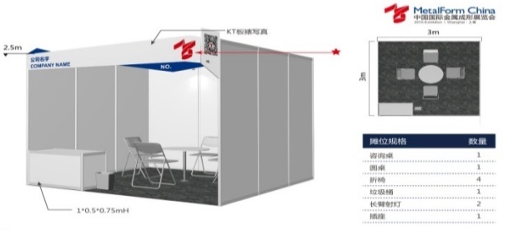 | 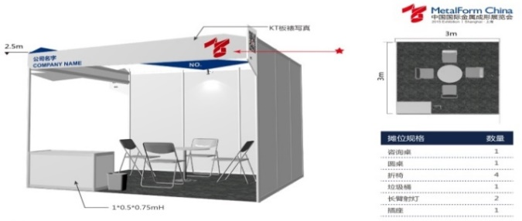
Style B
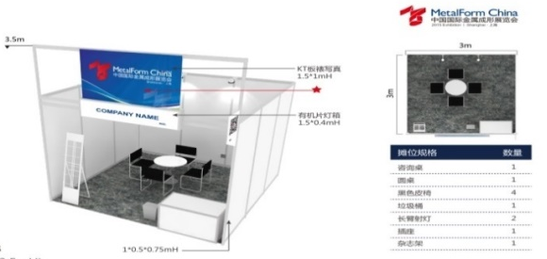 | 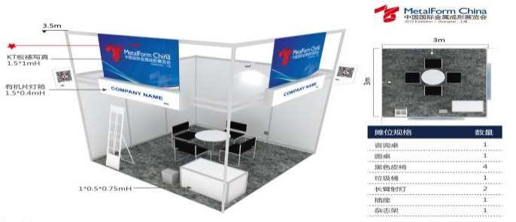
Style C
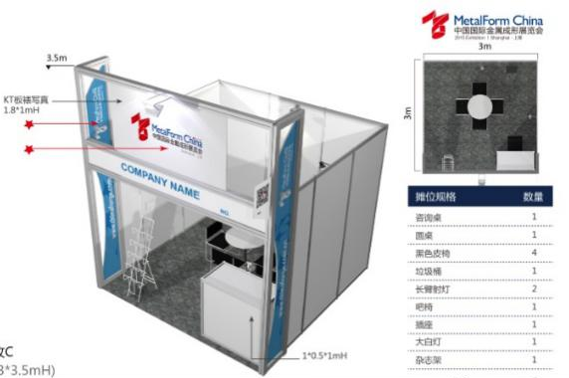 | 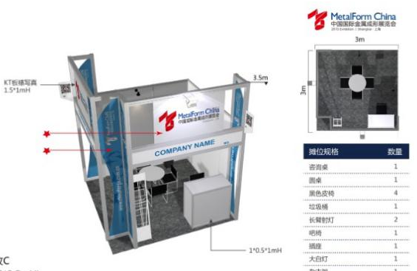

Attention：
- Please fill this form carefully so that we can provide you with accurate services.
- This Form is a collection form of exhibition intention, without the signature of legal person and the seal of the firm.
- If the booth is less than 36 m², it is agreed that the organizer shall designate the booth, and the booth number cannot be indicated in the contract.
- During the three months to one month of exhibition opening, the Organizer will designate all the booths, and include the information such as the booth map, booth number, booth disposition, move-in route, etc. in the <Notice of Participation> and mail it to the exhibitors who have settled the payment.

Applicant Signature： Date： D/M/Y

